ER MODEL…

Group members-

Shirish Kumar (190185)

Nenavath Parmesh (190119)

Suman Kumar (1901201)

Ranvijay Patel A. (1901156)

Assumptions: -

* There are two types of houses. First one is renthouse(rent_house) and second one is selling house (Sell_house).
* Rented houses can’t be bought and selling house can’t be rented.
* Here person owner(person_owner) is my sellers.
* 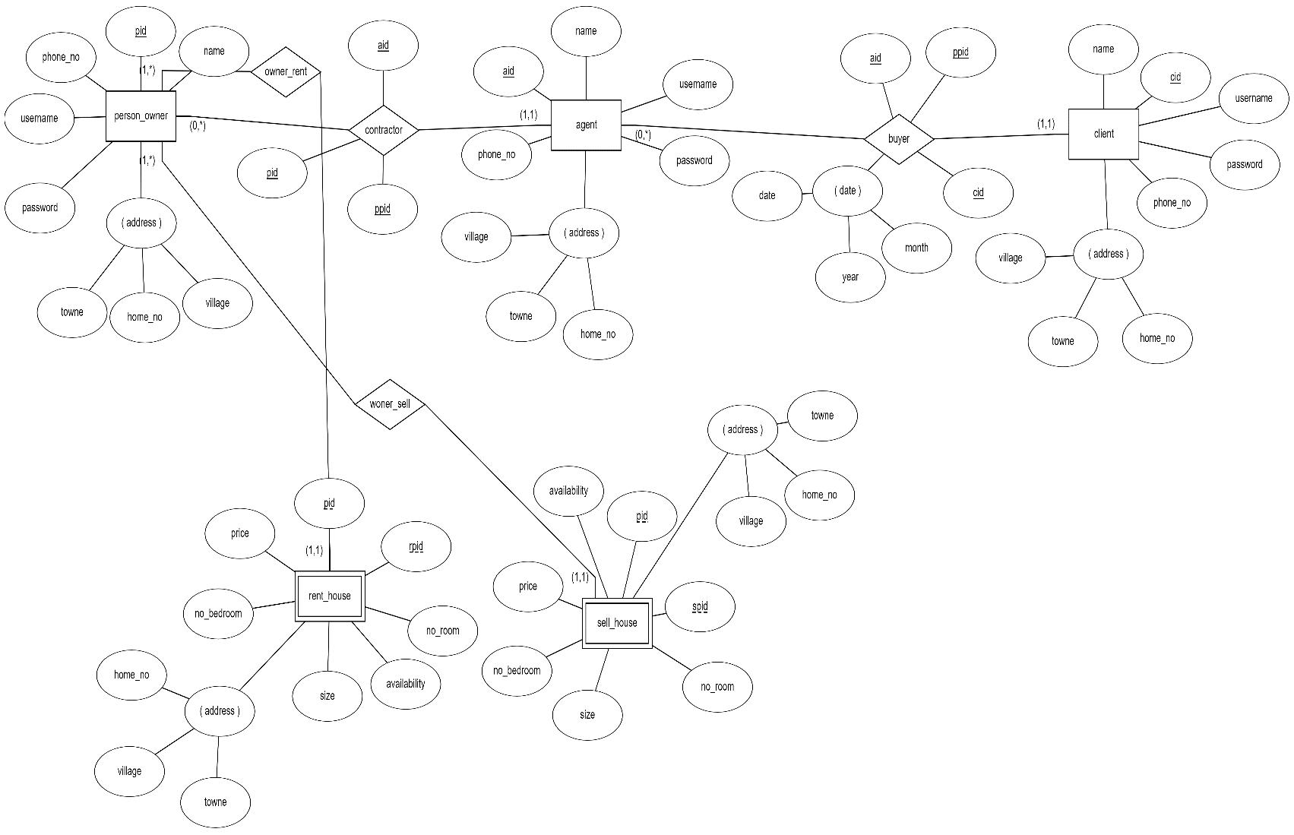Here agent is responsible for interacting with buyers and person owner(person_owner).